Appendix 2

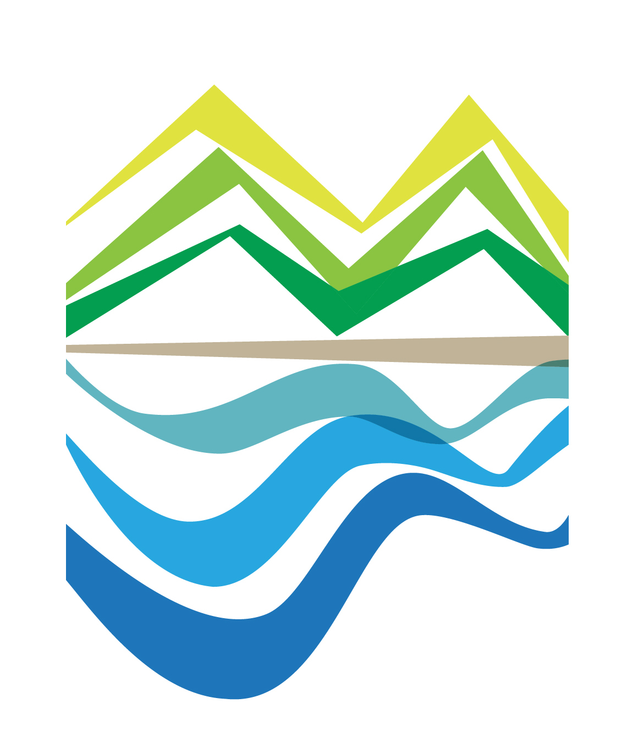**2017 East Coast Land Arts Festival**

**Resident Artist Application Guidelines**

1. Introduction to Land Arts Festival and This Year’s Creative Theme

In 2017, the East Coast National Scenic Area, Tourism Bureau, Ministry of Transportation (hereinafter referred to as ECNSA) will host the third annual East Coast Land Arts Festival. We invite artists to submit proposals to create installation arts that combine the natural environment, geographic landscape, and spatial aesthetics of the East Coast National Scenic Area. Four installation projects will be selected, and two international artists will be invited to create artwork onsite to present the unique natural leisurely aesthetics of the East Coast. The festival emphasizes onsite creation and local participation, focusing on the dialogue among art, nature and culture to adapt to the climate and ecological context of the East Coast. The purpose is to gather local and international artistic creativity through a modern cultural tourist strategy into accentuate the unique cultural and scenic landscapes of the East Coast of Taiwan.

**Theme: “Mother Island”**

The geographic basis of the “East Coast Land Arts Festival” is the long and narrow land mass situated between the coastal mountain range and the Pacific Ocean, 168 kilometers in length, extending southward from outside of Hualien City to Taitung City; home to the site of Paleolithic Changbin Culture (50,000 to 5,000 years ago) that presented the earliest evidence of human activity on the island of Taiwan. Thousands of years have passed, ten indigenous groups have found their home here, as well as the Han Chinese and a significant number of new immigrants from around the world also settled here with the total population reaching nearly over 50,000. With so many ethnic groups scattered around in such a long and narrow space where the mountains meet the ocean, its extending diversified and fluid character gave birth to unique symbiotic relationships, both inter-personally and between people and nature. Just like the intertidal zone, the exposed coastal area that belongs to both the land and the ocean where different realities overlap, its home to a rich ecological diversity and mothering an abundant marine life culture, a food bank from which the local Amis people are provided daily.

Therefore, this year's theme, based on the core concept of “Mother Island” will present the unique cultural and natural qualities of the East Coast through the creativity by artists' residencies.

1**. Hailing from the Mother Island to Meet the World**

Nourished by the cultural fertilizer of the East Coast, we elicited the perspective and prospect of “Hailing from the Mother Island to Meet the World.” In many of the Austronesian peoples' oral histories Taiwan, the “Mother Island,” is the origin from where their ancestors first embarked on their journey. In the contemporary society, we face a strong impact from globalization; all kinds of autonomy, whether of the land, ethnicity, or individuals, has been eroded into vagueness by the global economy and the Internet, where the elements of time and space are removed. Thus, ways to embrace the world while spreading roots on earth is the gift we would like to present to the world through the wonderful and poetic artworks from the “East Coast Land Arts Festival.”

**2. Typhoons are Not Enemies, But Friends in Synchronal Rhythm**

The natural power of the East Coast constantly reminds us how humble and limited human life is. The scorching sun bakes all day with intensity during the summer. The typhoon season starts from the beginning of summer and continues into late autumn, with typhoons threatening to land or pass by every ten days to two weeks, putting everything in perturbation as if waiting for the result of a lottery; and typhoons that bring forth tremendous wind gusts and rain in a short time, prepping the locals with optimism to always be ready to restart and have everything change in an instant. Otherwise, how can life take such collisions time after time? After the mid-Autumn Festival, the monsoon winds start blowing from the northeast, with strong gusts and mighty waves often matching the intensity of a passing typhoon. And this is coupled with the fact that it's located on the edge of where Eurasian plates push and crash into one another, which makes frequent earthquakes something ordinary.

Just like the meeting ground of sea and land, the bounty of the intertidal zone is shaped by the constant washing of the ocean waves. Hualien and Taitung, on the east coast of Taiwan, also known as “the last paradise,” gained their pristine beauty through the same process, being washed by the mighty force of nature again and again, which has not only created its majestic landscape, but also the highly intense and tightly interwoven symbiotic relationship between nature and humans.

The artwork of the East Coast Land Arts Festival is the extension of humans in nature, and inevitably it must face the harsh natural elements of the East Coast. Since our festival takes place during the typhoon season, we hope that artists' creative approaches can be based on the concept “Typhoons are not Enemies, but Friends with Whom We Share Our Lives” in terms of exploring creative ideology, selecting media and forms of presentation in order to create an artistic interpretation that is in sync with the rhythms of the East Coast.

There is no limit on the selection of media used in the artwork; it can be single or multiple materials, preferably natural materials such as wood, bamboo, rattan, stone, water, brass, metal, various plants, plant dye, and weaving. Please consider that artworks must be able to be displayed outdoors long-term when selecting materials. The artwork should also fit appropriately onsite in the right place in terms of its size and relation to the entire space.

The timing for resident artists to produce their artwork onsite is June 1- 30, 2017. The artwork then must be displayed for an additional four months at the designated location from July 1 to October 31, 2017 (including holidays).

**2. Event Organizers**

* 1. Main Organizer: East Coast National Scenic Area, Tourism Bureau, Ministry of Transportation
  2. Contracted Organizer: Mapaliw Taiwan

**3. Qualifications and How to Apply**

The festival is calling for four units of individuals or teams of any nationality, especially encouraging those artists who are familiar with the East Coast’s natural environment and cultural context, and are good at utilizing natural materials.

1. Submission Requirements:
2. Application form
3. Artist portfolio (including written and graphic illustrations) and resume
4. Residency proposal (including artistic concept, design size, materials, techniques, methods and schedule. The design plan must include a graphic illustration that integrates the artwork with the on-site location, which can be presented as models, pictures of 3D simulations, or hand drawings.
5. Budget plan (including all costs in design, creation, labor, materials, tools, transportation, accommodation and food, tax on the applicants; maximum $250,000NTD).
6. Eight copies of compilation of all the above, along with digital files on a single disc.
7. Submission Methods:
8. Special delivery or registered postal mail. Deadline 5pm, May 5th, 2017. No applications will be accepted after the deadline. (Please assure postal mail arrives in time.)
9. Please download the application from ECNSA website [www.eastcoast-nsa.gov.tw](http://www.eastcoast-nsa.gov.tw/) or the event website [www.teclandart.tw](http://www.eastcoast-nsa.gov.tw/或活動網站www.teclandart.tw下載)

**4. Sites for Installation**

Completed works are installed in the following locations (see map in appendix 2-2); the organizer reserves the rights to artistic spatial adjustment.

1. Jingpu Village, Feng Bin Township, Hualien County (Highway 11, 68K)
2. Xibulan Visitor Center (Highway 11, 68K by the New Changhong Bridge)
3. Kingkong Avenue, Changbin Township, Taitung County (Highway 11, 85K, Turning East on Road 13 Chang Guang Industrial Road)
4. Donghe Recreational Area (Highway 11, 131.5K)
5. Nanzhu Lake Village, Taitung (This site is reserved for an invited foreign artist)
6. Our Headquarters in Douli (This site is reserved for an invited foreign artist)

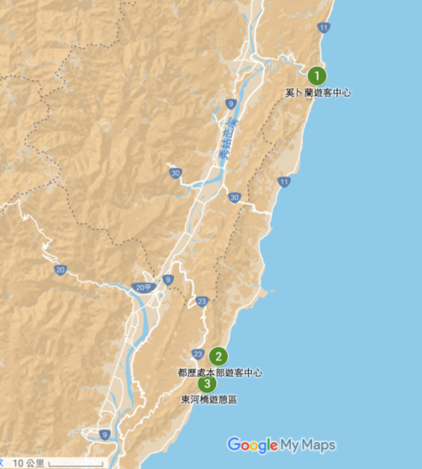

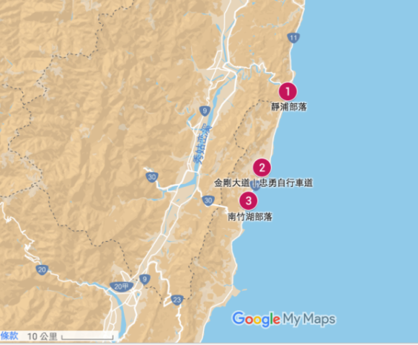

Sites for Installation

**5. Selection Methods**

1. The Selection Committee consists of organizers, experts and scholars who are familiar with the artistic, natural and ecological context.
2. Evaluate Priority: Integration of work and environment 30%, work uniqueness 30%, matching the festival's theme 20%, design feasibility 20%
3. Final results will be released before May 12, 2017 (depending on the actual decision-making situation).
4. Once the result is announced, execution of contract signing and artist residency will follow.

**6. Artists’ Rights and Obligations**

1. The organizers and artists will discuss and reach consensus on a designated site for execution and installation of the artwork.
2. For the artworks that are installed in the villages (Jingpu, Kingkong Avenue in Changbin, and Nanzhu Lake Village), the artists must cooperate with organizers to hold an explanatory meeting to communicate and collaborate with local villagers.
3. Artists' assistants who participate in the residency program are invited by the artists, and all expenses such as food, accommodation, insurance and tax, that are rendered by the staff including the artists themselves should be covered by the artists.
4. The artists should prepare their own creative tools. The organizers will provide an onsite structure to provide a covered space.
5. The maximum budget for each artwork project is $250,000NTD, which includes designing, creating, labor, materials, tools, transportation of artwork, food and accommodation, etc.
6. Right of Attribution: The creator has the moral rights to the artwork. The organizers have the ownership of the work, and rights to publish images of the artwork, including rights in research, photography, duplication, authorizing relevant merchandise, publication, press release, promotion, etc.
7. During the period of creating artworks, the artists must take measures to cope with the potential impact of typhoons by either suspending work or moving everything off the site. During the exhibition period, the artists should take preventative and recovering measures to cope with inevitable natural disasters or man-made damage. A warranty period will be included in the contract for signing, which is termed from the beginning date of the exhibition to March 31, 2018.
8. After being evaluated by the organizers, if a project is left incomplete due to personal reasons or is presented as immensely different from its original proposal, the artists will be disqualified and have to return all the related funding for the artwork creation and materials.
9. Artists must cooperate with the organizers to participate in the “Artistic Creativity Forum,” “Artistic Concept Explanatory Meeting,” “National Press Release,” “Art Festival Opening Event,” and assist in other relevant promotional and marketing activities.

**7. Contact Us**

Li Yun-Yi：email：aurora.lfox@gmail.com phone：0912267915

Wu Shu-Lun：email：wusulun@gmail.com phone：0926314951

Application Info Website：www .t e c l a n d a r t . t w

Facebook Event Page：TECLandArtFestival

**8. Relevant Important Dates**

1. Application Deadline: 5pm, May 5 (Friday), 2017
2. Results Released: May 12, 2017 (Depending on actual decision-making situation)
3. Artist Residency Forum: May 31 - June 2, 2017
4. Artist Residency Period: June 3 - 30, 2017
5. Artwork Exhibition Period: July 1 - October 31, 2017

**Appendix2-1**

ECSA Land Arts Festival Artist Residency

Application Form

|  |  |  |  |
| --- | --- | --- | --- |
| Title of Artwork |  | Artist / Team Name |  |
| Contact Person |  | Contact Telephone Number |  |
| Contact Address |  | e-mail |  |
| Intended Site for Installation | □Jingpu Village  □Kingkong Avenue in Changbin  □Xibulan Visitor Center  □Donghe Bridge Recreational Area | | |
| Submit Information | □Application Form  □Artist portfolio (including written and graphic illustration) and resume  □Residency proposal (including artistic concept, design size, materials, techniques, methods and schedule; the design plan must include a graphic illustration that integrates the artwork with the on-site environment, which can be presented as models, pictures of a 3D simulation or hand drawings.  □Budget plan (including all costs in design, creation, labor, materials, tools, transportation, accommodation and food, tax on the applicants; maximum $250,000NTD).  □Other_________________ Please type, print out and bind. No restriction on number of pages.  □Eight copies of all the above mentioned documents.  □One copy of a disc containing all of the above mentioned documents in digital format. | | |
| I hereby agree to follow all of the specifications of the East Coast Land Arts Festival Artist Residency Application Guidelines, and that all the relevant information provided here is correct.  To East Coast National Scenic Area, Tourism Bureau, Ministry of Transportation and Communications  Signature：  Month/Day______________________2017 | | | |

**Appendix2-2- Photos with Explanations of Main Sites for Installation**

1. **Jingpu Village**

Jingpu, called “Ca’wi” in Amis, means the flatland in the valley. Jingpu's geographical location is in Fengbin Township, Hualien County, among the mountains at the mouth of Xiuguluan Creek. Its rich estuary ecology has contributed to the village's major industry as a fishery. Having seafood as their main staple, the living culture of going fishing at dawn is still a living legacy. The Amis villagers are highly autonomous. Their guided tours operated from the village and community building has gradually matured over recent years. They offer local cuisine, eco-tourism and more on regular basis. With convenient accessible transportation and easy living conditions, it makes for a suitable site for a resident artist to install artwork.

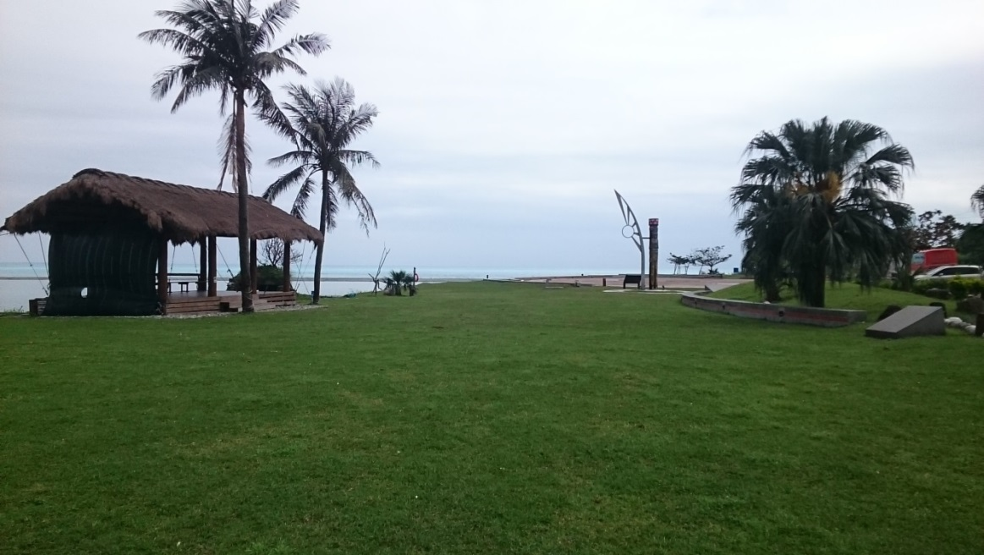

**Possible site for art installation: The mouth of Xiuguluan Creek, next to the Sun Square on the grassy land between the tribal thatch hut and the sundial**

1. **Xibulan Visitor Center: Integration of artistic creation with architecture is recommended**

The limestone boulders on Xiuguluan Creek riverbed are washed and carved by water year-round into white colors similar to jade, and are named “Xiugu Rinsed Jade.” Xibulan Visitor Center used this imagery as their blueprint of the design concept, applying white colored paint that resembles stone material on the outside, while using an aluminum woven grid shaped similar to Xiugu Rinsed Jade for shading the structure. With its bright appearance it is different from the traditional sloping roof style, and an eye-catcher for tourists. The grand opening of “New Pacific No. 1 Shop” on October 2nd, 2015, took place in the Xibulan tourist center. Its interior is inspired by tribal elements and designed with warm woodwork, which not only offers its original function as a tourist center, but also creates a brand new space by combining multiple business operations of a bookstore and coffee shop. It also serves as a platform to sell handicrafts produced from the villages, as well as an information hub among various villages on the East Coast. The design style of its second floor is simplistic and soft, allowing tourists and volunteers to feel at home on the East Coast, with the concept of collaboration in tourist activities to become a base for exchange among travelers, volunteers and villagers. Xibulan Visitor Center is located at the entry of Changhong Bridge, and is highly visible from Highway 11. The easy living conditions of the building are suitable for resident artists to create work based on the original architectural body.

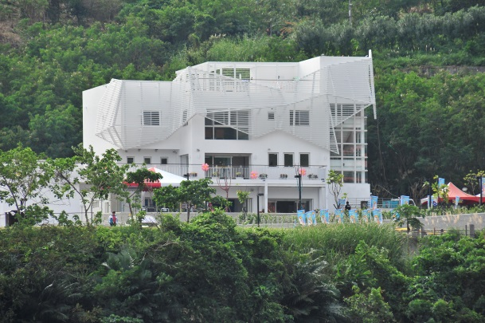 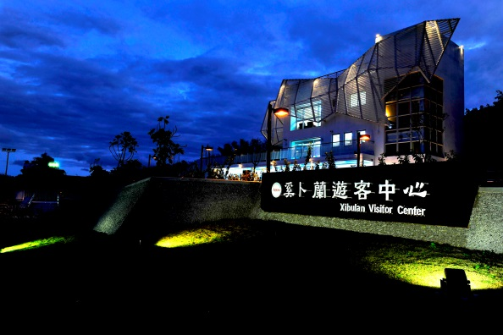

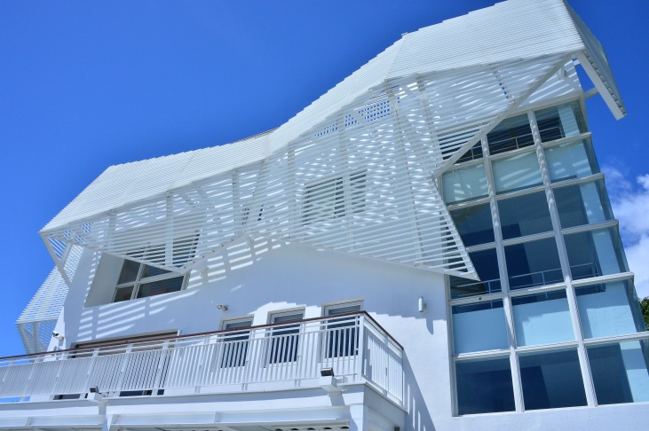

1. **Kingkong Avenue (Chung Yeung Bike Path) – The artwork is recommended to be created without destroying the structure of the pavilion**

Kingkong Avenue, at 85K on Highway 11 in Chang Guang Village, Changbin Township, Taitung County, was named Ciwkangan, literally meaning “rocky pit.” It is a gorgeous village facing the ocean with a mountainous backdrop. The most famous landmark is the “Kingkong Mountain” on the west side of the coastal mountain range; under the cunning interplay of mountainous terrain and skylight, a giant gorilla appears to stand out on the mountain peak, hence it was named Mount Kingkong and became a key landmark of the Chang Guang community. Still today, the village retains many beautiful landscapes of fields. When entering Chang Guang Village, along the East 13 Line, the Chang Guang Industrial Road going west, the straight Kingkong Avenue is plainly seen. Standing on the road, endless terraces on both north and south sides neatly align below Mount Kingkong and the Pacific Ocean. With the ocean breeze blowing, golden rice stalks sway in the wind like ripples on the waves, echoing with the sounds of the ocean. With its majestic boundless view, the seemingly endless Kingkong Avenue is like a shortcut going into a mysterious kingdom. The closer we approach Mount Kingkong, the more viewing potential we get of the many vast natural landscapes of the Pacific Ocean and Chang Guang Village. This area has became a popular tourist destination, attracting many tourists with large and small-scale sporting and cycling events. Surrounded by beautiful scenery, the easy living conditions of the nearby Changbin Town and Chang Guang Village are good, and so the festival selected the middle part of the avenue, where the pavilion is, to be the site for installation. The artwork should be combined with the pavilion and the wooden platform, following the principle of not damaging its structure.

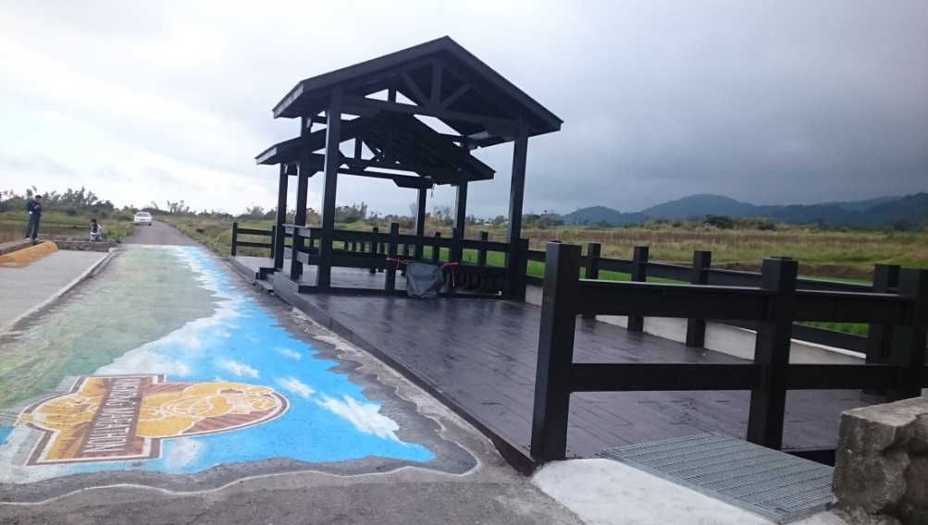

1. **Donghe Bridge Recreational Area: Recommended to install work on the old Donghe Bridge**

Donghe Bridge Recreational Area is located near Mawu Cave Creek river mouth, both the new and old bridges cross the green creek side by side, as green mountains reflect on the river’s surface. South of the bridge is Donghe Village, and north of the bridge is the entry to Dongfu Highway, connecting to Fuli in Hualien County. Donghe Bridge was built in 1930, designed by Japanese engineer, headmaster Yoshida. In order to cope with the terrain while keeping the view of the boulders in the river, half of the bridge was designed in the shape of an arch, while the other half was supported by column structures, showing an interesting contrast between the two sides. It is such a rarely seen bridge design, one that optimally integrates with the natural environment, and was listed as one of Taiwan's one hundred historic and architectural sites by the Council for Cultural Affairs. The newer red steel arch Donghe Bridge was built in 1992 while the Coastal Highway was under widening construction, downstream from the old Donghe Bridge. The New Donghe Bridge looks simple and dandy, with a wooden walking path laid on top of the bridge, and a view of the Pacific Ocean. The designated site is on the old Donghe Bridge, under the design principle of not rendering any damage to the structure of the old bridge.

